**BABCOCK UNIVERSITY, ILISHAN-REMO,**

**OGUN STATE, NIGERIA**



**TECHNICAL REPORT OF STUDENT INDUSTRIAL WORK EXPERIENCE SCHEME (SIWES)**

**CARRIED OUT AT**

**PRUNEDGE TECHNOLOGIES LIMITED**



**PRESENTED TO THE**

**DEPARTMENT OF COMPUTER SCIENCE**

**BY**

**KOLAWOLE, OLUWAGBEMILEKE**

**20/1797**

**COMPUTER SCIENCE**

**FROM FEBRUARY 1ST 2022 TO JUNE 30TH 2022**

**CERTIFICATION**

This is to certify that I, Kolawole Oluwagbemileke, hereby declare that the information in this report was written by me. It is true that I did the student industrial work experience scheme (SIWES) otherwise known as Industrial Training (IT) between February 1st and June 30th 2022.

Student’s Matric No: 20/1797

Student’s Signature:

SIWES Coordinator/Supervisor:

Oral IT-Defense Coordinator:

SIWES Class Code: CS277

Student name: KOLAWOLE, OLUWAGBEMILEKE

Matric: 20/1797

Email: milekekolawole@gmail.com

Level: 300 Level

Course of study: Computer Science

Mobile number: 08100550405

Company name: Prunedge Development Technologies Limited

Postal Address & traceable location of company: 32, Ade-Ajayi Street, Ogudu GRA, Ogudu, Lagos, Nigeria.

Geographical state: Lagos State

Company Email: info@prunedge.com

Company Phone Number: +2348061999591

Company website: <https://prunedge.com/>

Staff strength (Number of staff): 100-150

Name of Industry Based Unit Head (immediate supervisor): Cyril Okonkwo

Mobile number (Supervisor): +234735607052

**ACKNOWLEDGEMENT**

I give my unreserved and profound gratitude to the Almighty God for the ever-abiding presence right from the time I was conceived to this present moment.

It was a great privilege to have an internship with this great Organization, I had the opportunity for learning and self-development. The period of time that I spent in Prunedge Development Technologies Limited for my internship from February 1st 2022 to June 30th 2022 was a memorable one, as it advanced my insight in cybersecurity and helped me to find my potential in the utilization of programs which would perpetually shape and impact my expert exercises just as encouraging my self-awareness and improvement in the closest future.

This report would not have been possible without the contribution and collaboration of others and therefore my sincere gratitude and appreciation goes to the following:

To Almighty God who provided me with good health and long life, without which I could not have completed this internship report.

To Babcock University, for providing me with the opportunity to participate in the SIWES programme.

To my industry-based supervisor in the person of Mr. Okonkwo Cyril for his technical support and constant supervision which contributed immensely to my personal development. I also thank him for his guidance which was a remarkable force that enabled me to succ**es**sfully complete the internship program.

To the rest of the staff in Prunedge Development Technologies Limited, their support and guidance which helped me to overcome the challenges I faced during the five months of my SIWES.

**TABLE OF CONTENT**

**CHAPTER ONE**: **INTRODUCTION OF SIWES**

1.1 Introduction to SIWES

1.2 Aim and Objectives of SIWES

CHAPTER TWO

2.0 About the institution

2.1 Brief history of Prunedge

2.2 Vision of Prunedge

2.3 Mission of Prunedge

2.4 Organizational structure of Prunedge

2.5 Services rendered by Prunedge

**CHAPTER THREE: RESPONSIBILITIES AND PARTICIPATION**

3.1 Summary of Activities undertaken

**CHAPTER FOUR: WORK EXPERIENCE AND KNOWLEDGE GAINED**

4.1 Knowledge and Skill Acquired

4.2 Challenges faced

**CHAPTER FIVE: SUMMARY AND CONCLUSION**

5.1 Summary

5.2 Conclusion

**LIST OF PICTURES**

Picture 2.4.1: Prunedge’s Organizational Structure

Picture 2.5.1: Me at work

Picture 2.5.2: Me at work

Picture 2.5.3: The other Babcock interns and I

Picture 2.5.4: The other Babcock interns and the CEO

Picture 3.1.1: Me with my teammates

Picture 4.1.1: Me working with another team to review a product

Picture 4.2.1: Me working

Picture 4.2.2.1: Certification of passing the Certified Network Defender certification

Picture 4.2.3.1: Certification of passing the Certified Secure Computer User certification

Picture 4.2.4.1: Certification of attendance for the Ethical Hacking Core Skills course

Picture 4.2.5.1: Certification of passing the Certified Ethical Hacker (ANSI) certification

Picture 4.2.6.1: Certification of passing the Certified Ethical Hacker (Practical) certification

Picture 4.2.7.1: Tryhackme Certificate of track completion

Picture 4.2.7.2: Tryhackme Certificate of track completion

Picture 4.2.7.3: Tryhackme Certificate of track completion

Picture 4.2.7.4: Tryhackme Certificate of track completion

Picture 5.1.1: Me in front of the office logo after being retained

**ABSTRACT**

This report is on a portion of the significant tasks I did during my 6 months SIWES program with the company. SIWES aims and objectives are to provide students with practical experience of what they have been taught theoretically in school. Prunedge Development Technologies Limited is an indigenous IT company which provides software solutions to various organizations. In the company I was able to develop my Security skills by improving on my security knowledge from the Security course we took in New Horizon that allowed us take the Certified Secure Computer User (CSCU) certification exam. The report focuses on the experiences I gained from SIWES at Prunedge Development Technologies Limited and I would recommend they keep the SIWES program going so that students in the higher institution can gain more practical experiences which will prepare them ahead of the labour market demand.

**CHAPTER ONE: INTRODUCTION OF SIWES**

1. HISTORICAL REVIEW OF SIWES

The Student Industrial Work Experience Scheme (SIWES) is a program created by the Industrial Trust Fund (ITF) for students in higher institutions of learning. SIWES was established by ITF in 1973 to solve the problem of lack of adequate practical skills preparatory for employment in industries by Nigerian graduates of tertiary institutions. The Scheme exposes students to industry-based skills necessary for a smooth transition from the classroom to the world of work. It affords students of tertiary institutions the opportunity of being familiarized and exposed to the needed experience in handling machinery and equipment which are usually not available in the educational institutions.

Participation in Industrial Training is a well-known educational strategy. Classroom studies are integrated with learning through hands-on work experiences in a field related to the student’s academic major and career goals. Successful internships foster an experiential learning process that not only promotes career preparation but provides opportunities for learners to develop skills necessary to become leaders in their chosen professions.

One of the primary goals of the SIWES is to help students integrate leadership development into the experiential learning process. Students are expected to learn and develop basic non-profit leadership skills through a mentoring relationship with innovative non-profit leaders.

By integrating leadership development activities into the Industrial Training experience, we hope to encourage students to actively engage in non-profit management as a professional career objective. However, the effectiveness of the SIWES experience will have varying outcomes based upon the individual student, the work assignment, and the supervisor/mentor requirements. It is vital that each internship position description includes specific, written learning objectives to ensure leadership skill development is incorporated.

Participation in **SIWES** has become a necessary precondition for the award of Diploma and Degree certificates in specific disciplines in most institutions of higher learning in the country, in accordance with the education policy of the government. Operators - The ITF, the coordinating agencies (NUC, NCCE, NBTE), employers of labour and the institutions. Funding - The Federal Government of Nigeria, Beneficiaries - Undergraduate students of the following: Agriculture, Engineering, Technology, Environmental, Science, Education, Medical Science and

Pure and Applied Sciences. Duration - Four months for Polytechnics and Colleges of Education, and Six months for the Universities. (ITF, 2015)

1.1 DEFINITION OF SIWES

SIWES is an acronym which means Students Industrial Work Experience Scheme.

1.2 AIMS AND OBJECTIVES OF SIWES

1. The aims and objectives of SIWES are to provide students with practical experience of what they have been taught theoretically in school.

2. Prepare the understudies for the modern work circumstance they are probably going to meet after graduation.

3. It enables the student to develop an area of interest where he/she can specialize in the future

4. The Industrial training also may provide future employment opportunities for students that performed excellently during their Industrial Training (SIWES).

5. SIWES students will develop employment records/references that will enhance employment opportunities.

6. SIWES will provide students the opportunity to understand informal organizational interrelationships.

7. SIWES Students will be able to outline at least five specific goals with several staff members by comparing performance with job duties and develop a draft plan with staff to accomplish performance needs, supervision plan and rewards.

8. SIWES Students will be able to develop a draft agency or project budget and will be able to identify methods of obtaining revenue to support the budget.

9. SIWES Students will be able to provide tools to use in prioritizing tasks of an assigned project and create with staff a tentative schedule for completion based on these tasks.

**CHAPTER TWO: COMPANY PROFILE**

2.1 PRUNEDGE DEVELOPMENT TECHNOLOGIES, WHO THEY ARE.

Prunedge is a technology company focused on building solutions to solve the world’s greatest problems. They actively work to put a smile on people's faces by showing them the immense benefits of technology and delivering impact-focused and outstanding solutions and inventions. They have office branches in Lagos, Abuja, USA and UK with the Lagos branch being the Headquarters.

We're an enterprise technology solutions company focused on delivering value through process improvement within the private and public sectors, with special emphasis on the social impact of our products and projects and their ability to ultimately improve the quality of lives of people across the continent and globe.

2.2 VISION OF PRUNEDGE DEVELOPMENT TECHNOLOGIES

To solve the world’s greatest problems through technology.

2.3 MISSION OF PRUNEDGE DEVELOPMENT TECHNOLOGIES

They exist to innovate and create affordable technological solutions that solve day to day human problems by increasing the efficiency of systems and processes within the social, commercial and public sector.

2.4 ORGANIZATIONAL STRUCTURE OF PRUNEDGE DEVELOPMENT TECHNOLOGIES

In the diagram below is the organizational structure of the company.

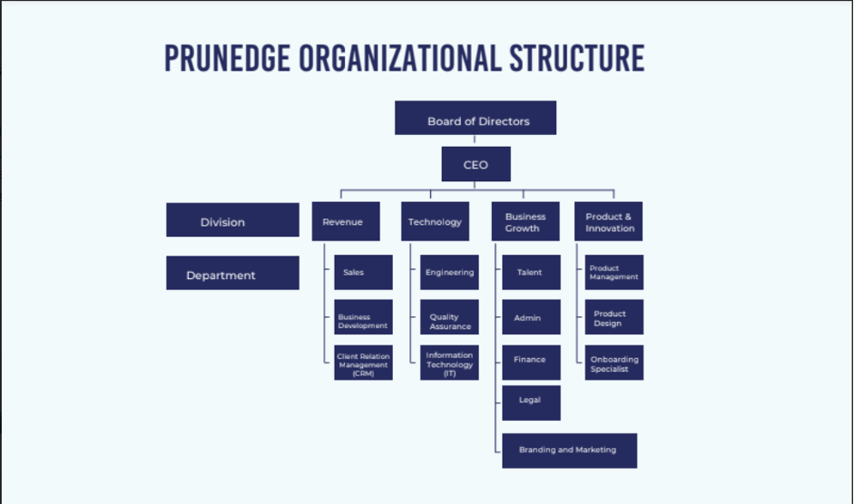

Picture 2.4.1: Prunedge’s Organizational Structure

2.5 Prunedge is an enterprise technology solutions company focused on delivering value through process improvement within the private and public sectors, with special emphasis on the social impact of our products and projects and their ability to ultimately improve the quality of lives of people across the continent and globe.

The services rendered are:

● **Product Envisioning & Design**

Achieve extraordinary outcomes with your products through data-driven user experience.

○ Ideation and Envisioning

○ User Interface & Experience Design

○ Market and User Research

○ User Interface & Experience Review

● **Software Solution Development**

Build and deploy quality, scalable and secure digital products fast

○ Web, Mobile & Desktop Application Development

○ Custom Enterprise Solution Development

○ Systems Integration & API Development

○ Quality Assurance and Software Testing

● **Data Engineering & AI Solution**

Leverage data at scale to improve efficiency, decision making and company growth

○ Industry-Specific AI/ML Solution Development

○ Voice Assistant and Chatbot Development

○ Data Analysis and Data Maturity Assessment

○ Business Intelligence, Data Analytics, and Visualization

○ Big Data Management and Business Metrics Analysis

● **IoT Solution Development**

Revolutionize your business operations by leveraging connected devices

○ Industry Specific IoT Solution Development

○ Embedded System Development

○ Wireless Sensor Network

○ IoT Advisory

● **Emerging Technology Solutions**

Leverage advanced technologies to differentiate and create impact in the marketplace

○ Blockchain Based Solution Development

○ Augmented, Virtual and Mixed Reality Solution Development

○ AR/VR/MR Consulting

● **Cybersecurity Consulting**

Adopt the right security strategy and practice to safeguard your business and customers

○ Vulnerability Assessment and Penetration Testing

○ Mobile Application Security Assessment

○ Cloud Infrastructure Security Assessment

○ Social Engineering, Phishing Testing, and Simulation

○ Cyber Incident Response and Digital Forensics

○ IT Security Services (Design, Implementation, and Monitoring)

● **Hardware & Cloud Infrastructure**

Procure IT hardware and cloud services quickly reliably and cost effectively

○ IT Hardware Procurement and Installation

○ Enterprise Cloud Solution License Procurement

○ Enterprise Cloud Service Management & Support

● **Network Service**

○ On-Premise to Cloud Data Center Migration



Picture 2.5.1: Me at work



Picture 2.5.2: Me at work



Picture 2.5.3: The other Babcock interns and I



Picture 2.5.4: The other Babcock interns and the CEO

**CHAPTER THREE: RESPONSIBILITIES AND PARTICIPATION**

3.1 RESPONSIBILITIES AND PARTICIPATION

In the 5 months I spent in Prunedge Development Technologies, I was responsible for:

a. helping the team perform any minor scans that they needed to do

b. writing automation scripting codes for tasks

c. making sure the network remained secure



Picture 3.1.1: Me with my teammates

**CHAPTER FOUR: WORK EXPERIENCE AND KNOWLEDGE GAINED**

4.1 ACTIVITIES DURING SIWES

In totality, I spent my SIWES learning about the field of Cybersecurity. I learnt about a vast range of concepts and techniques during the period that has taken me from an absolute beginner level to an intermediate level in the field. I started my internship with no knowledge about technical concepts in security. The only thing I knew about while starting my SIWES was the knowledge I had gained from classes for the Certified Secure Computer User taught to us in Babcock University of which I took the certification and passed. During my SIWES program, I took multiple certification exams, as Cybersecurity is a very certification-based field, and this was the basis of my learning. The certification exams I took were from EC-Council and they came with a guide and syllabus. I would be breaking down the things I did during my SIWES into each certification and explaining the scopes of each one. I passed all the certification exams I took which certify that I had a good understanding of all the course contents.



Picture 4.1.1: Me working with another team to review a product

4.2 Knowledge gained during the SIWES program

I spent the bulk of my SIWES internship placed on personal learning tracks. I was slated to take several certification exams of which had complete learning paths. I also severally engaged in Capture the Flag activities conducted by my team lead. The sole purpose of the certification exams is to verify that I have gained the required knowledge for the exam and that I possessed a deep understanding of the concepts that I was tested on. I would be going over the concepts that were contained in the courseware of the certification exams I took and going over a brief of the other courses I took too.



Picture 4.2.1: Me working

4.2.1 Ethical Hacking course from Udemy

This was the first course that I took on Cybersecurity. In Cybersecurity, there are multiple fields and before my SIWES, I already had an idea of the particular field that I wanted to go into which is Vulnerability Assessment and Penetration Testing (VAPT). Knowing this, I went on Udemy and took a course on Ethical Hacking which introduced me to the basic concepts of hacking all-round. The name of the course was “Learn Ethical Hacking from Scratch”. The instructor was Zaid Sabih and he ran through the course from the setting up of the environment for practicing and learning hacking to performing complex hacks. It is very necessary that whoever wants to learn ethical hacking sets-up a lab environment because hacking is not something that can be practiced on live network, no matter the intentions of the person.

The first section of the course was on setting up the hacking lab, where I got to learn how to use VMware and installing Linux on it as well as other operating systems, some intentionally left vulnerable so they can be easily hacked. After getting Kali Linux installed, we went on to learning how to navigate the Linux terminal, as this is a crucial skill to learn to be successful as a hacker. The Linux terminal is where almost everything goes down. Most of the commands are done there and it is necessary to know how to navigate the system (or systems that you’ve gained access to so you can move on to privilege escalation) to be a successful hacker.

In the next section of the course, we moved on learning about Network Hacking. This is where I was deeply introduced into the concept of penetration testing. Penetration Testing (also known as Pen Test or Ethical Hacking) is an authorized simulated attack on a computer system, performed to evaluate the security of the system. The course instructor started with network hacking because basically everything that can be hacked can communicate with another device and it makes use of networks. To understand how to hack a system, you have to understand how to hack the network and to understand how to hack the network, you have to understand the network and for this reason, we started the course by first understanding how computers and everything else connected to the internet communicate with each other. The instructor explained what Mac addresses are and how they can be changed.

For the main network hacking, it was broken into 3 different types of attacks, namely; Pre-Connection Attacks, Gaining Access and Post-Connection Attacks. For the Pre-connection attacks, he introduced the basics of packet sniffing and then went on to explain the 2 Wi-Fi bands (2.4Ghz & 5Ghz frequencies). After this we went on to learning about targeted packet sniffing attacks and then Deauthentication attacks.

· Packet sniffing: This is a process where data packets flowing across the network are detected, captured and observed. The packets are usually intended for another system.

· Deauthentication attacks: This is simply the process of disconnecting any device from the network.

After the Pre-connection attacks, we moved on to the Gaining access part of network hacking. Here we were introduced to what it meant to gain access into a network and the several ways it can be done. There were several techniques that were taught and they were WEP cracking techniques, Fake Authentication attacks, ARP Request replay attack, WPA and WPA2 cracking (with and without a wordlist) and how to capture handshakes. After each section in the course where the instructor taught a technique to hack into a system, he also explained how to defend against it in the best possible way.

Moving on from the Gaining access part of network attacks, we went on to the post-Connection attacks (The attacks that come after a hacker has already gained access to a network). In this section, the instructor taught about a wide area of topics as the possibilities are endless once the access to a network of a system has already been gained. He explained in details what ARP poisoning is, how to intercept network traffic, how to use Bettercap for ARP spoofing, spying on network devices (capturing passwords, visited websites, user browser history), creating custom spoofing scripts to automate tasks, bypassing HTTPS, bypassing HSTS, bypassing HSTS recap, injecting JavaScript code, and then he went on to explaining, deeply, how to use Wireshark—the famous packet capture tool.

· ARP poisoning: ARP spoofing, ARP cache poisoning, or ARP poison routing, is a technique by which an attacker sends Address Resolution Protocol messages onto a local area network. It is used to perform man-in-the-middle attacks.

· Man-In-The-Middle Attack: This is an attack whereby an intruder snoops on information that is meant for another destination. This can either be a passive attack (he snoops on the information and doesn’t act on it or change anything) or an active attack (he snoops the information and actively intercepts it, then passes it on to the intended destination). It is a very popular attack.

After the Network hacking section, we moved on to system hacking. The name of this section was called “Gaining access to computers”. The concept of this section is to gain access to any computing device, mostly making use of the information that was previously learnt. The instructor taught us on gaining access to computer systems and used a Windows machine and a Linux machine as victims. He talked about attacking the computer from two sides. The server side and the client side. The server side does not need any human interaction as it does the bulk of its operation with the servers. It mostly applies to web servers and computers that run automatically without the use of a user. The main way of gaining entry in this approach is through the operating system or the applications that are installed. The second way of gaining access to a computer is the client-side attack. This one relies heavily on the user of the computer to do something. It could range from things like clicking a button, running an alleged update or visiting a website. This relies heavily on social engineering to succeed a lot of times.

Social Engineering: Social engineering is a manipulation technique that exploits human error to gain private information, access, or valuables. In cybercrime, these “human hacking” scams tend to lure unsuspecting users into exposing data, spreading malware infections, or giving access to restricted systems.

The gaining access section was broad and the instructor taught a lot of things. A number of the things that were explained by him were how to install the Metasploitable virtual machine (a virtual machine that is made vulnerable to attacks on purpose so people can use it to practice) to how to hack a remote server using the Metasploit framework (a very powerful hacking tool. It is commonly referred to as the swiss army knife of hacking). We were also introduced to Nexpose which is a tool that is used for scanning. Nexpose can be used for scanning servers and we were shown how to scan and analyze the scan results.

In this same section, we were introduced to a bank of techniques that can be used for gaining access into a computer system. We were deeply introduced to social engineering and various tools such as Maltego (used for profiling), BeEF and a couple others.

4.2.2 Certified Network Defender (Network Security)

After already taken my CSCU Certification from New Horizons, I decided I would love to obtain more certifications in the field of Cybersecurity and I went ahead to purchase the voucher for the Vulnerability Assessment and Penetration Testing (VAPT) track of courses from EC-Council. Each certification comes with a course outline with textbooks, videos and practice labs.

The Certified Network Defender certification is the first on the list of the certification track. It gives an introduction to networking while keeping security of the network in kind. The computer network has become more and more complex over the past few years and so has the threats to its security. The Certified Network Defender (CND) course has focused on helping the network defenders to understand how to effectively deal with such issues that challenge the security of a network.

This course presents a defensive stand to network security. It enhances the skills of a network defender so as to analyze the internal and external network security threats, how to proactively minimize their effect by developing necessary security policies, designing a defense strategy, implementing the security mechanisms, and by responding to security incidents in a timely manner.

The course covers all major domains in such a manner that the reader will be able to appreciate the way network security mechanisms have evolved over time; as well as gain insight into the fundamental workings relevant to each domain. It is a blend of academic and practical wisdom, supplemented with tools that the reader can readily access and obtain hands-on experience. The emphasis is on understanding various network security elements, updating the already deployed security mechanisms, spotting any known or possible vulnerabilities, and hardening security implementations using various tools. You will read about the defense mechanisms that are most widely used such as the firewalls, IDS, digital signatures, the secure configuration of various every-day applications, and a comprehensive set of policies that are to be enforced in the network to secure it from network breaches. I took the course listed below are the objectives that were covered by the course:

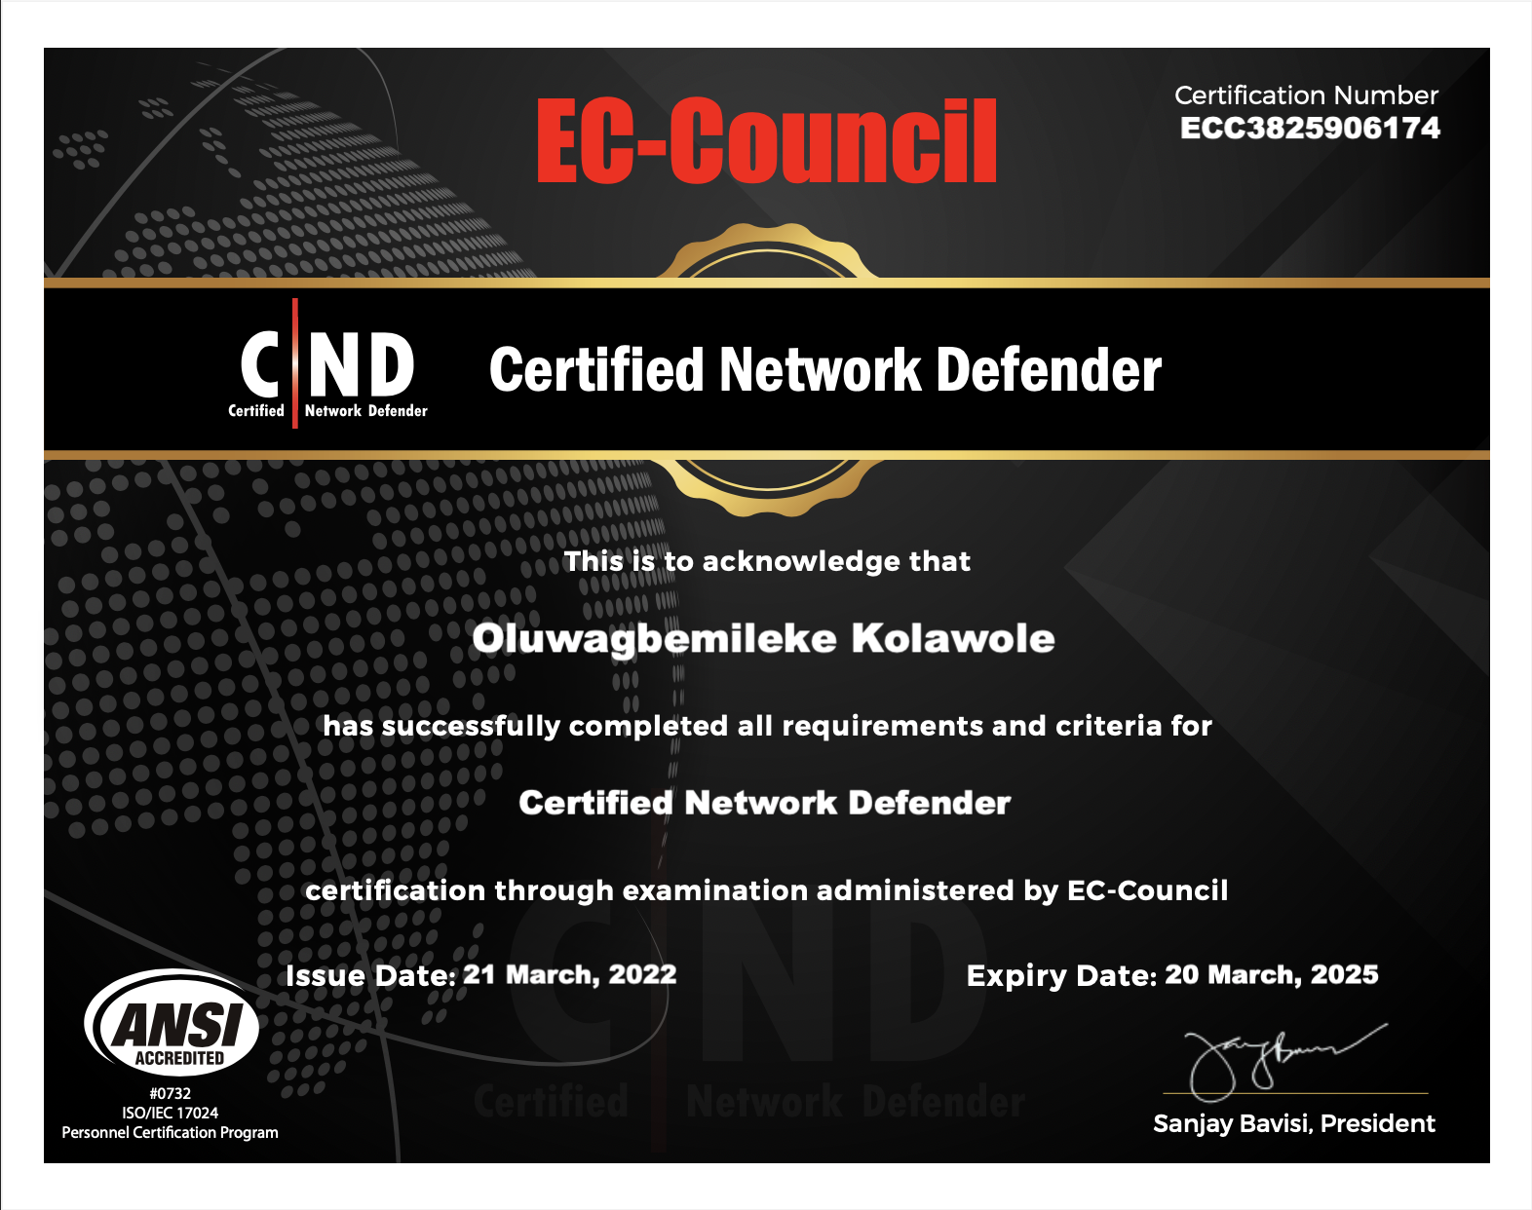

Picture 4.2.2.1: Certification of passing the Certified Network Defender certification

4.2.3 Security Awareness: Certified Secure Computer User (CSCU)

The purpose of the CSCU training program is to provide students with the necessary knowledge and skills to protect their information assets. This class will immerse students in an interactive learning environment where they will acquire fundamental understanding of various computer and network security threats such as identity theft, credit card

fraud, online banking phishing scams, viruses and backdoors, email hoaxes, sexual predators and other online threats, loss of confidential information, hacking attacks, and social engineering. More importantly, the skills learnt from the class help students take the necessary steps to mitigate their security exposure.

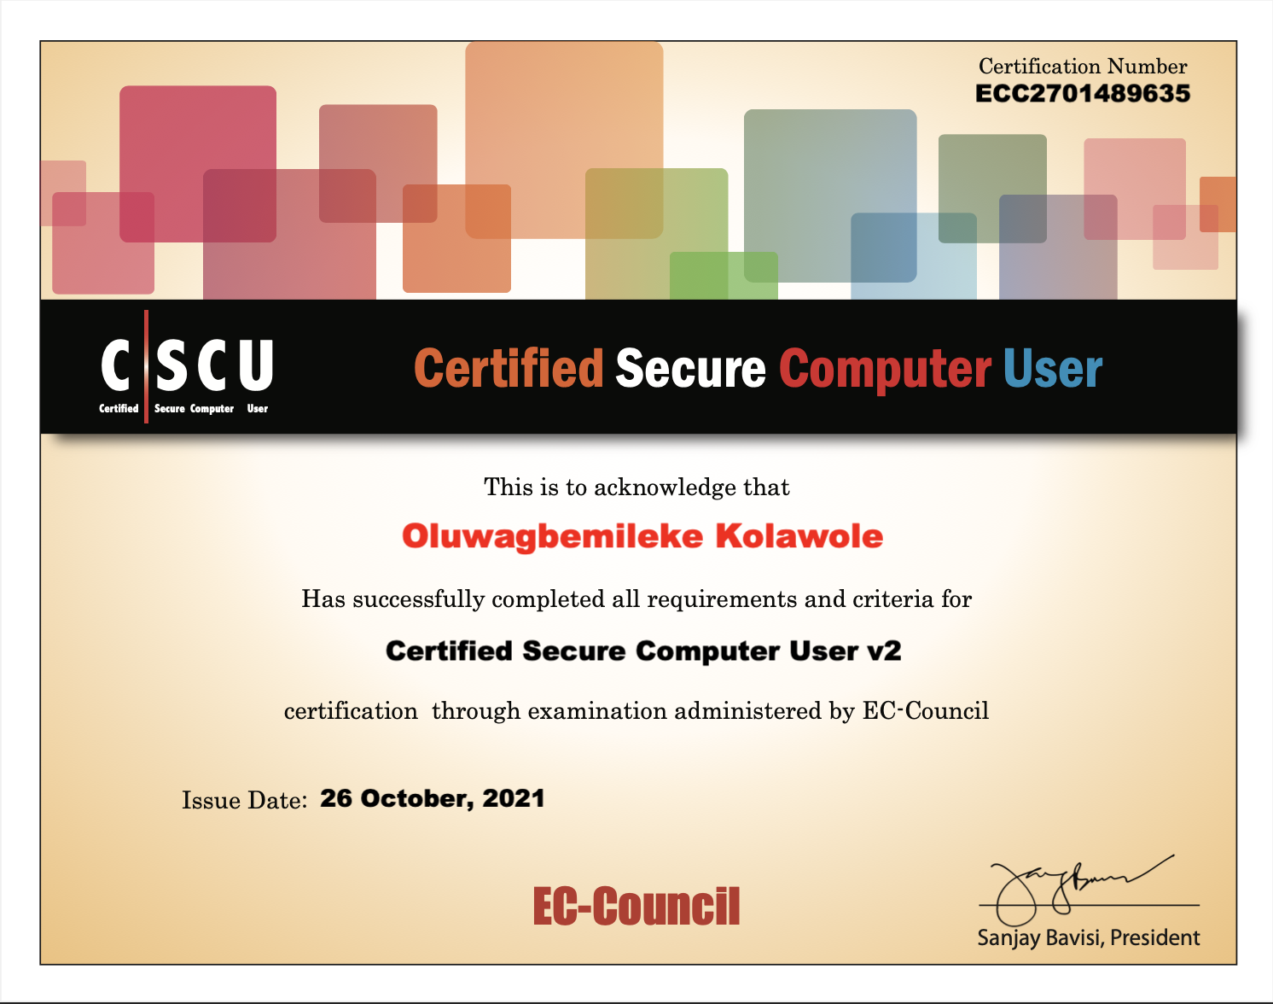Picture 4.2.3.1: Certification of passing the Certified Secure Computer User certification

4.2.4 Ethical Hacking Core Skills

This course was a basic introduction to ethical hacking and all it entails. It gave an introduction to the necessary security skills. The EHCS course did not have an exam as it was just an introductory course. I took the course and below is my certificate of attendance.

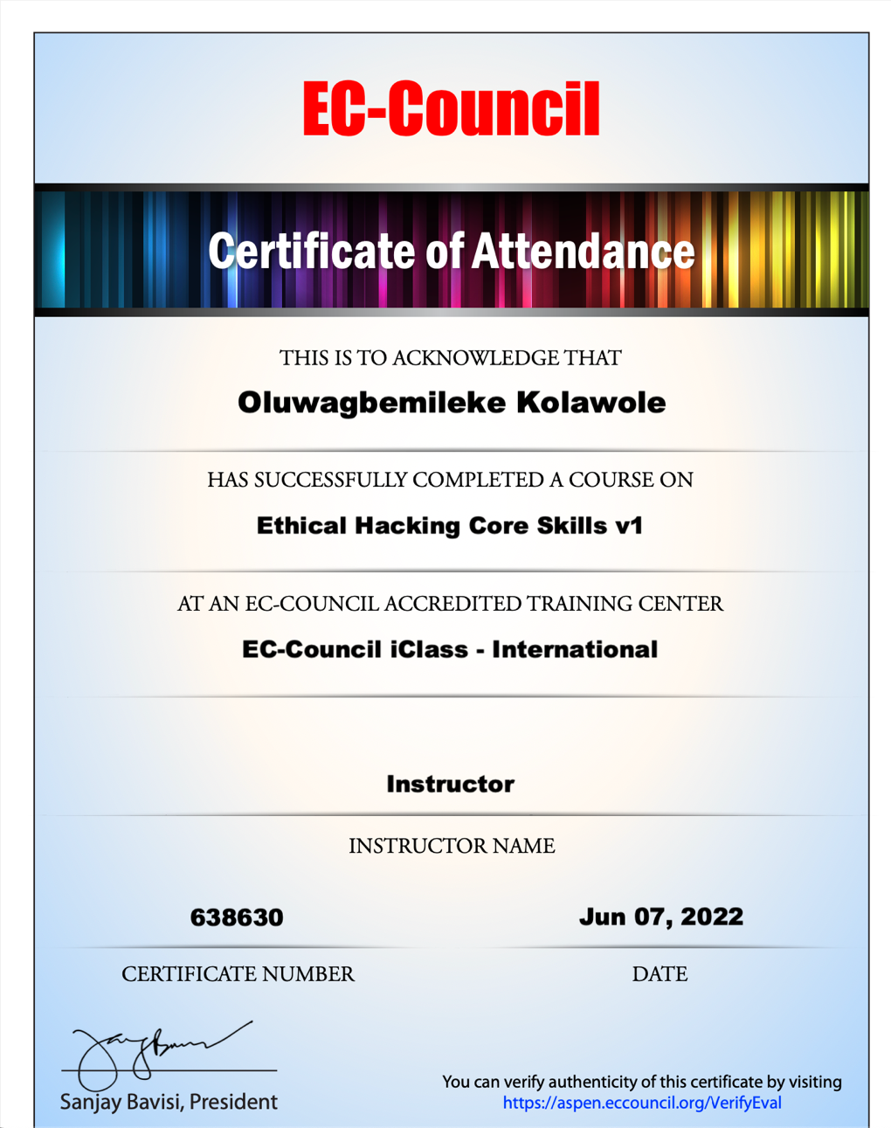

Picture 4.2.4.1: Certification of attendance for the Ethical Hacking Core Skills course

4.2.5 Certified Ethical Hacker (Penetration testing, theory)

The Certified Ethical Hacker (CEH) program is the core of the most desired information security training system any information security professional will ever want to be in. As the security mindset in any organization must not be limited to the silos of a certain vendor, technologies or pieces of equipment, this course was designed to provide you with the tools and techniques used

by hackers and information security professionals alike to break into an organization. As it is put, “To beat a hacker, you need to think like one” and this course prepares you for just that. This program will immerse you into the Hacker Mindset so that you will be able to defend against future attacks. It puts you in the driver’s seat of a hands-on environment with a systematic ethical hacking process.

Here, you will be exposed to an entirely different way of achieving optimal information security posture in their organization; by hacking it! You will scan, test, hack and secure your own systems. You will be taught the Five Phases of Ethical Hacking and thought how you can approach your target and succeed at breaking in every time! The five phases include Reconnaissance, Gaining Access, Enumeration, Maintaining Access, and covering your tracks.

If you want to stop hackers from invading your network, first you've got to invade their minds.

Computers around the world are systematically being victimized by rampant hacking. This hacking is not only widespread, but is being executed so flawlessly that the attackers compromise a system, steal everything of value and completely erase their tracks. The goal of the ethical hacker is to help the organization take preemptive measures against malicious attacks by attacking the system himself; all the while staying within legal limits. This philosophy stems from the proven practice of trying to catch a thief, by thinking like a thief. As technology advances and organization depend on technology increasingly, information assets have evolved into critical components of survival. If hacking involves creativity and thinking 'out-of-the-box', then vulnerability testing and security audits will not ensure the security proofing of an organization. To ensure that organizations have adequately protected their information assets, they must adopt the approach of 'defense in depth'. In other words, they must penetrate their networks and assess the security posture for vulnerabilities and exposure. The Ethical Hacker is an individual who is usually employed with the organization and who can be trusted to undertake an attempt to penetrate networks and/or computer systems using the same methods as a Hacker. Hacking is a felony in some countries. When it is done by request and under a contract between an Ethical Hacker and an organization, it is legal. The most important point is that an Ethical Hacker has authorization to probe the target. The CEH Program certifies individuals in the specific network security discipline of Ethical Hacking from a vendor-neutral perspective. The Certified Ethical Hacker certification will fortify the application knowledge of security officers, auditors, security professionals, site administrators, and anyone who is concerned about the integrity of the network infrastructure. A Certified Ethical Hacker is a skilled professional who understands and knows how to look for the weaknesses and vulnerabilities in target systems and uses the same knowledge and tools as a malicious hacker.

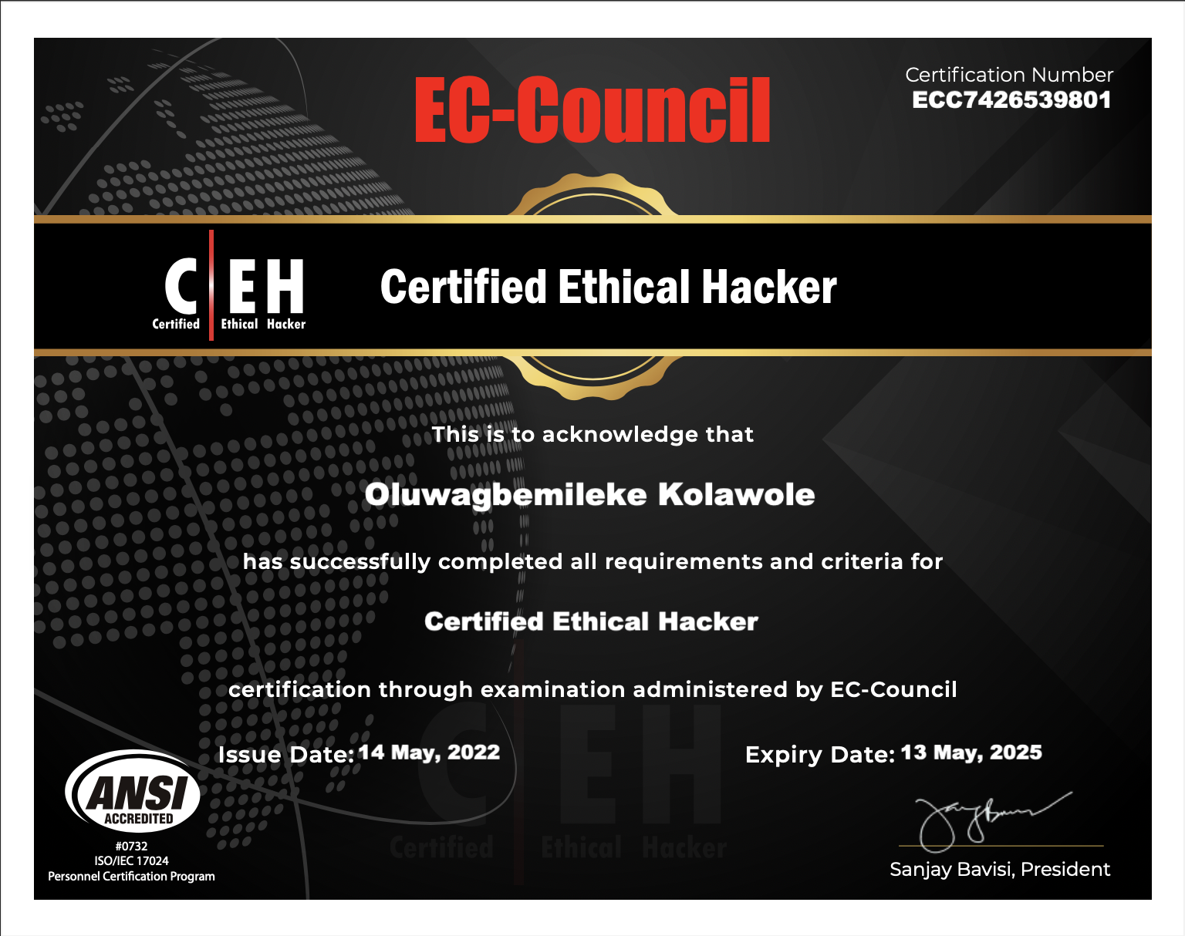

Picture 4.2.5.1: Certification of passing the Certified Ethical Hacker (ANSI) certification

4.2.6 Certified Ethical Hacker (Penetration testing, practical)

The Certified Ethical Hacker (Practical) exam is the practical exam of the CEH ANSI exam. Here, the concept that were explained in the ANSI would be put to the test. The exam consists of 20 questions in a controlled lab environment. To get this certification, one would need to get over 16 marks out of the total possible 20 points.

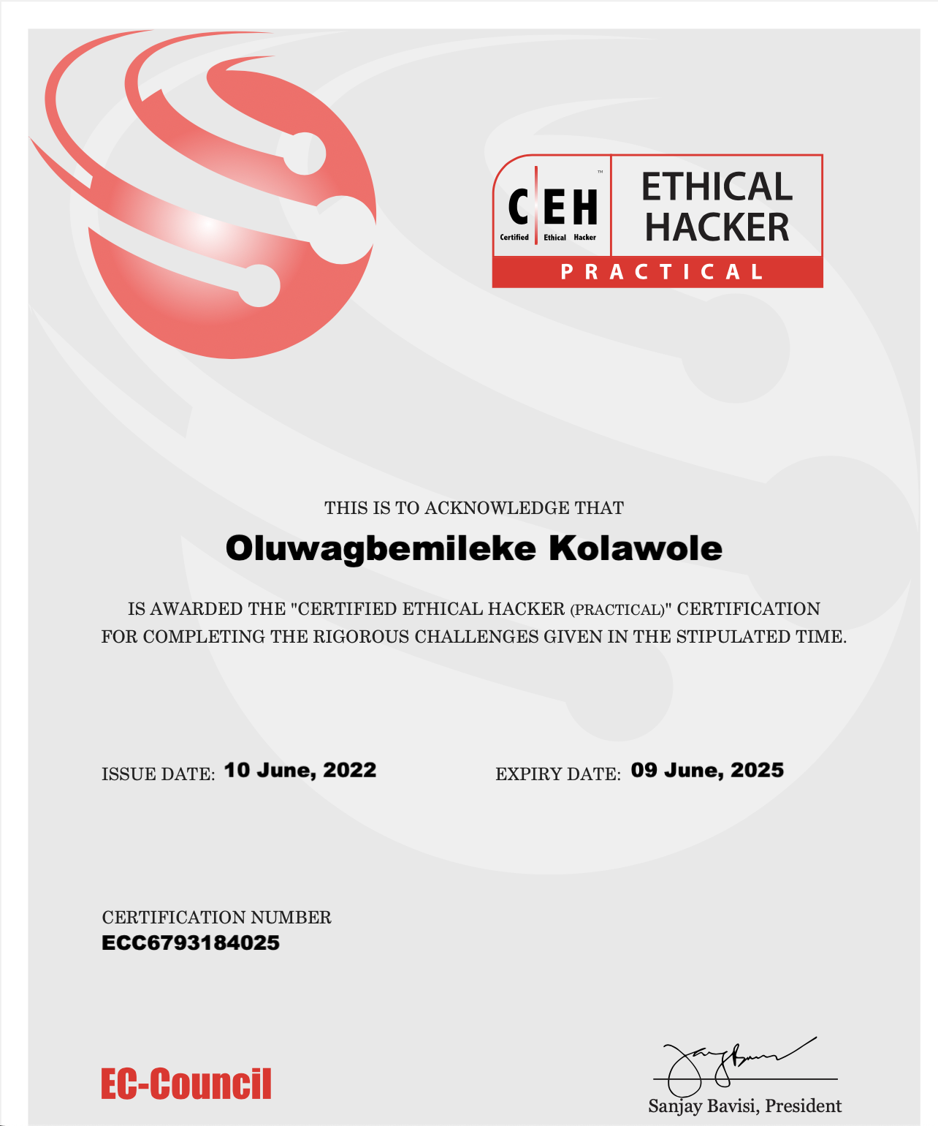

Picture 4.2.6.1: Certification of passing the Certified Ethical Hacker (Practical) certification

4.2.7 Tryhackme learning

During the course of my internship, I also utilized a platform called Tryhackme which is a user-friendly website that helps people learning Cybersecurity to learn in a very engaging environment. There are multiple learning paths of which I completed a good number of them. Below are a couple of the certificates that I got using the platform.

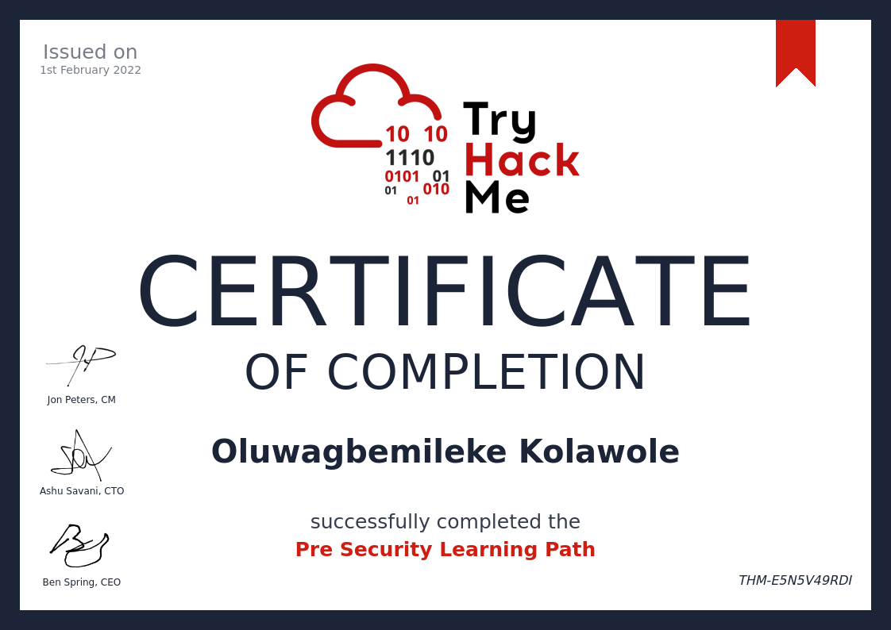

Picture 4.2.7.1: Tryhackme Certificate of track completion

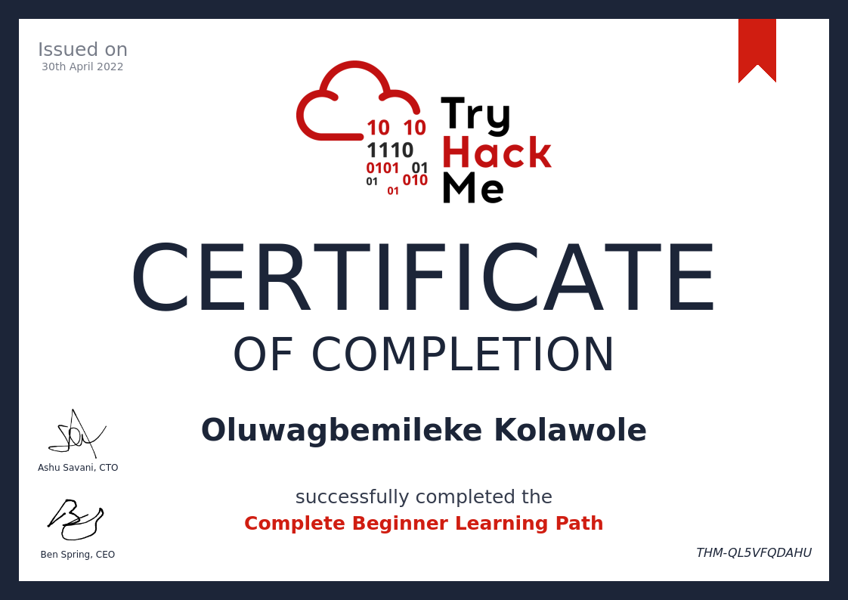

Picture 4.2.7.2: Tryhackme Certificate of track completion

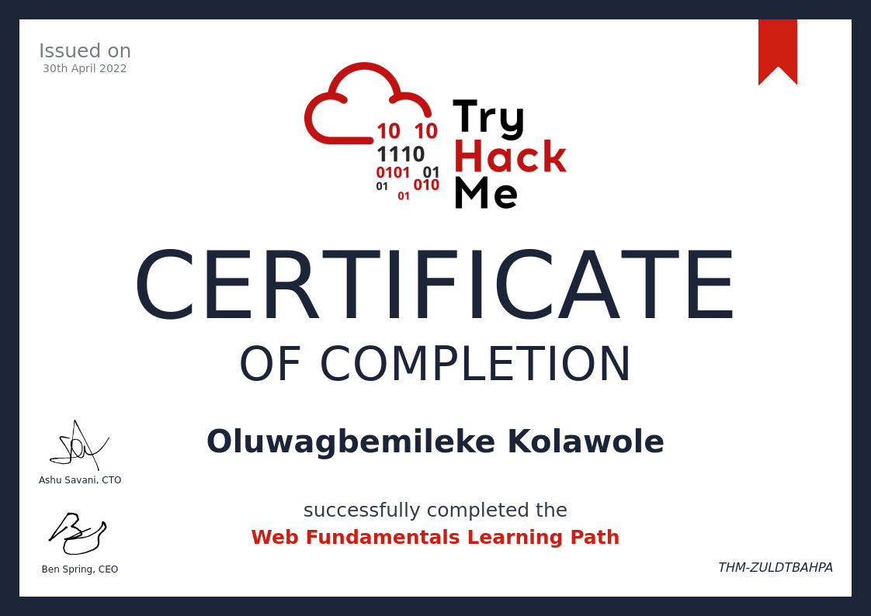

Picture 4.2.7.3: Tryhackme Certificate of track completion

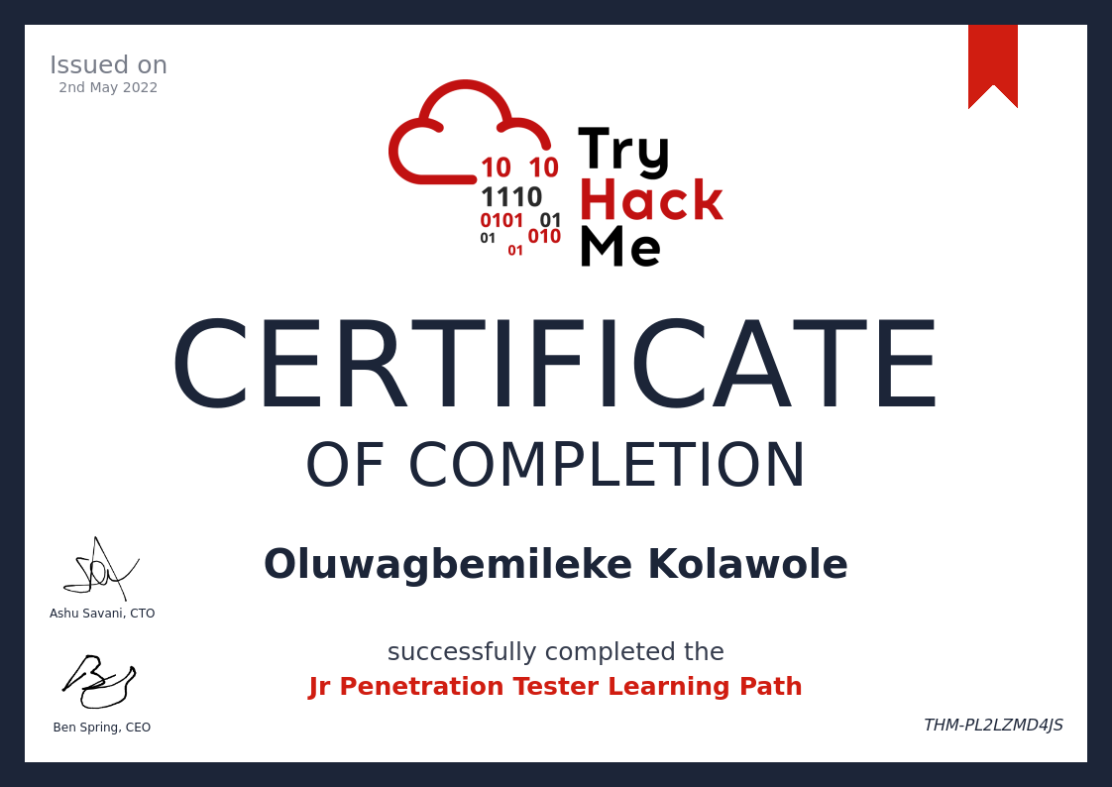

Picture 4.2.7.4: Tryhackme Certificate of track completion

4.2 Challenges faced during the SIWES program

Thankfully, I did not face any major challenges during my SIWES program. I was lucky enough to get a place to stay in Lagos that was very convenient and I was being paid the money I spent on the commute to the office and back. The only thing I would say I was not really pleased with was the fact that my department was not getting jobs to work on so we could only simulate hacks. The companies in Nigeria do not pay a lot of attention to security, hence, they do not actively look for security consultants that can help test their infrastructure. Asides this, everything else was good. I had a good workspace; the work environment was very pleasant and I had an enlightening experience all-round.

CHAPTER FIVE: SUMMARY AND CONCLUSION

5.1 Summary

This report is on a portion of the significant tasks I did during my 5 months SIWES program with the company.

The Students Industrial Work Experience Scheme (SIWES) is a curricular provision of the Universities in Nigeria, where students of most technological-based courses are given the privilege to work with a company, industry, firm, or Ministry, that is related to their course of study, in order to get acquainted with the Methodologies, Instrumentation, Procedures, and mode of Processing acquired data and also to get them prepared for the life after School. This scheme has been a real benefit to me as most of the things I now know, I had no knowledge of prior.

It has always been an aspiration of mine to develop myself more practically in the programming and web development area. I saw this dream come true in this six-month industrial training as a proper path was shown to me. I was trained on the basics of security concepts, policies and techniques. I covered multiple syllabi and courses over the short time, bagging 4 professional certifications (CND, CEH, CEH Practical, CEH Master) in the process while I’m currently preparing for another one. It is also worthy of note that I was retained in the company and I currently still work there as an Associate Cybersecurity Engineer.



Picture 5.1.1: Me in front of the office logo after being retained

Outside security, I acquired new attributes which includes the ability to relate with people in a much friendly and respectful manner, how to be disciplined, punctual, more responsible and manage resources more effectively and efficiently.

5.2 Conclusion

My SIWES experience was a brilliant and energizing one since I had the opportunity to learn a parcel of new things and I have a nitty gritty knowledge into what life after school would look like. I had the chance to apply the hypothetical information I acquired at school with the down to earth hands-on experience at the organization. It additionally empowered me to work on friendly abilities through transformations I had with my functioning partners. I trust I have a more profound comprehension of my chosen course of study in regard to programming.

I accept that SIWES ought to be made required for all students who are learning at tertiary level regardless of their course of study to empower them to know what really goes on in the real world as pertaining to their course.